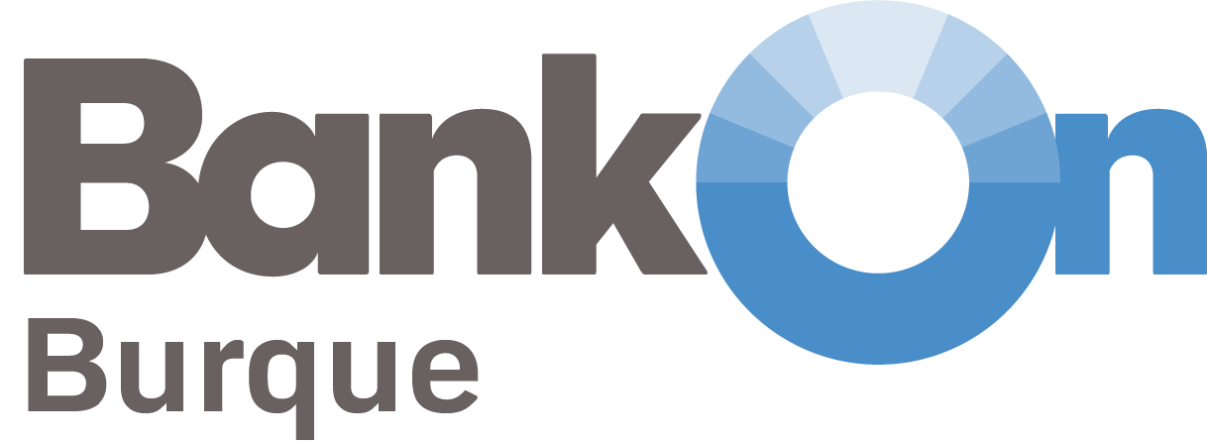

Coalition Partnership Agreement
Participation

This document (“agreement”) establishes the guidelines for eligibility and participation in the Bank On Burque Coalition. This is not a legally binding agreement and serves to express the intention to participate and understanding of expectations as a partner in the Bank On Burque Coalition.

Statement of Principles and Shared Goals

The national Bank On platform supports local coalition efforts to improve individual and family financial stability by connecting consumers to safe, affordable checking accounts (Bank On certified accounts).

Bank On Burque is a City of Albuquerque economic inclusion initiative for connecting individuals and families to Bank On certified accounts available in the Albuquerque community. Ensuring that low-cost, no overdraft, no-surprise-fee bank and credit union accounts are an option for unbanked and underserved individuals.

The Bank On Burque Coalition membership generally come from the following sectors: financial institutions with a Bank On certified account, municipal leaders and public agencies, community and social service organizations, federal and state banking regulators, and philanthropic partners and advocates.

In addition to connecting people to Bank On certified accounts, Bank On Burque Coalition goals are to also raise public awareness, target outreach to unbanked populations, and expand access to financial education.
All Coalition Members
All Coalition Member Organizations will be recognized on the Bank On Burque website and benefit from the reciprocal relationships that occur in a community network with opportunities to work in multi-sector workgroups.
All Coalition Member Organizations will designate a staff member(s) with decision making authority for any committee or workgroup they would like to participate on. They will ensure that their organization supports and participates in coalition meetings and efforts.
All Coalition Member Organizations will schedule Bank On Burque presentations for their staff / branch personnel to increase awareness and will have the option to share information about Bank On Burque / Bank On certified accounts on their websites or other media and marketing.

Financial Institutions with a Bank On Certified Account
Financial institutions with a Bank On certified account will benefit from marketing and public relation efforts in connection to general marketing campaigns as well as program integrations they choose to participate in.
Financial institutions will provide quarterly common measurements as defined in the Financial Institution Partner Agreement to assist with “Telling the Bank On Burque Story” and evaluating overall success in our community for connecting people to Bank On certified accounts. Financial institutions are encouraged to join the Bank On National Data Hub and report yearly Bank On account data.
Program Integration Partners
Program integration partners are social service organizations that provide direct services and either provide payments to clients and/or provide some type of financial education for low-to-moderate income clients.
Program integration partners will benefit from marketing and public relation efforts in connection to their program integrations and financial institution partnerships.
Program integration partners will provide quarterly common measurements, client stories, and program specific data as defined in the Partner Integration Agreement to assist with “Telling the Bank On Burque Story” and evaluating overall success of targeting priority populations for connecting to Bank On certified accounts.

We acknowledge and agree to participate in the Bank On Burque Coalition in accordance with this partner agreement.
Today’s Date Click or tap to enter a date.
Entity/Organization Name:Click or tap here to enter text.
Representative’s Name: Click or tap here to enter text.
Title: Click or tap here to enter text.
Email: Click or tap here to enter text. Phone: Click or tap here to enter text.
We represent the following sector: (Choose one)
☐ Financial Institution ☐Municipal Leader/Public Agency ☐Community/Social Service
☐Federal/State Banking Regulator ☐Philanthropy ☐Advocate
☐ Other Click or tap here to enter text.
We are interested in being a program integration partner: ☐Yes ☐No ☐NA

